Summer Industry Internship – I Report
on
Google AI Specific Tools
During
II Year II Semester Summer

Submitted to
The Department of Computer Science and Engineering
In partial fulfillment of the academic requirements of
Jawaharlal Nehru Technological University
For
The award of the degree of

Bachelor of Technology
in
Computer Science and Engineering

By

V. Sai Sri Lohitha 22311A0569
M. Sumedha 22311A0572
K. Varun Chandra 22311A0570

Dr. K C Sreedhar Associate Professor


Sreenidhi Institute of Science and Technology
Yamnampet, Ghatkesar, R.R. District, Hyderabad - 501301

Affiliated to
Jawaharlal Nehru Technology University
Hyderabad - 500085
Department of Computer Science and Engineering
Sreenidhi Institute of Science and Technology
Department of Computer Science and Engineering

CERTIFICATE

This is to certify that this Summer Industry Internship – I Report on Internship carried out in “Google AI Specific Tools”, submitted by V. Sai Sri Lohitha (22311A0569), M. Sumedha (22311A0572), K. Varun Chandra (22311A0570) in the year 2024 in partial fulfillment of the academic requirements of Jawaharlal Nehru Technological University for the award of the degree of Bachelor of Technology in Computer Science and Engineering, is a bonafide work in summer industry internship that has been carried out during II B Tech CSE II semester, will be evaluated in III B Tech CSE I Semester. This report has not been submitted to any other institute or university for the award of any degree.

Dr. K C Sreedhar Dr . Aruna Varanasi
Associate Professor Head, Department of CSE
Department of CSE
Internship Coordinator

External Examiner
Date:-
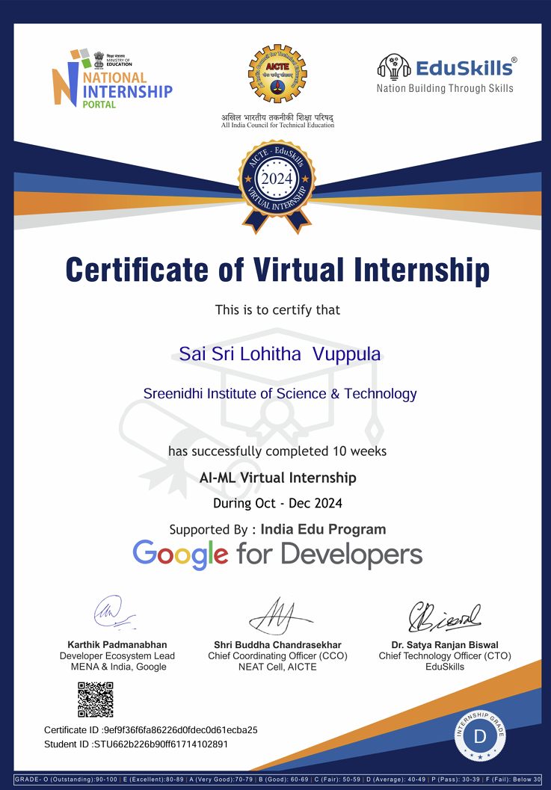

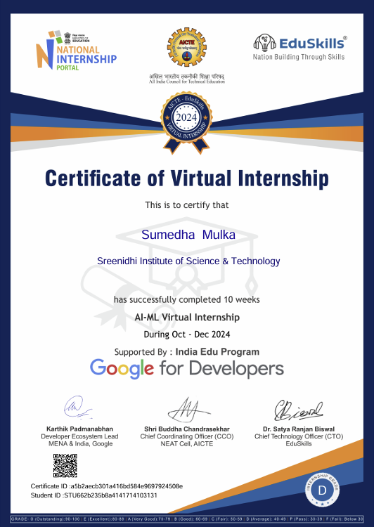

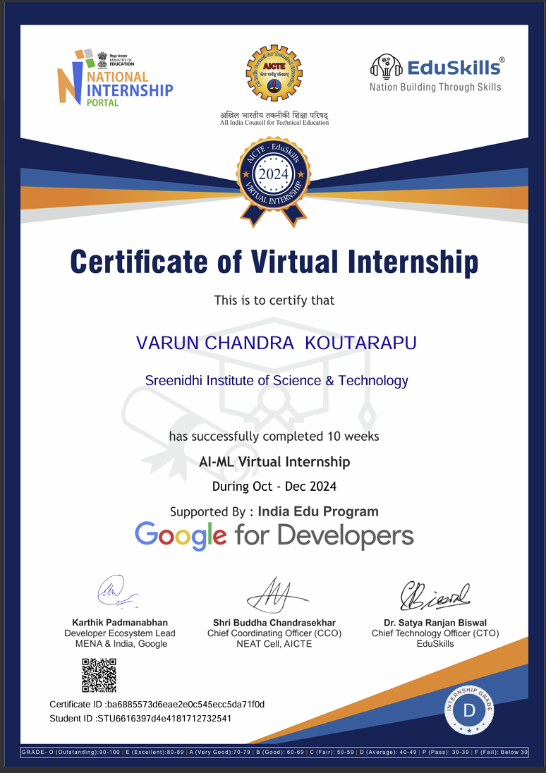

DECLARATION

We, V. Sai Sri Lohitha (22311A0569), M. Sumedha (22311A0572) and K. Varun Chandra (22311A0570), students of SREENIDHI INSTITUTE OF SCIENCE AND TECHNOLOGY, YAMNAMPET, GHATKESAR, studying IIIrd year Ist semester, COMPUTER SCIENCE AND ENGINEERING solemnly declare that the Summer Industry Internship-I Report, is submitted to SREENIDHI INSTITUTE OF SCIENCE AND TECHNOLOGY for partial fulfillment for the award of degree of Bachelor of technology in COMPUTER SCIENCE AND ENGINEERING.

It is declared to the best of our knowledge that the work reported does not form part of any dissertation submitted to any other University or Institute for award of any degree

V. Sai sri lohitha 22311A0569
m. sumedha 22311A0572
k. varun chandra 22311A0570

ACKNOWLEDGEMENT

I would like to express my gratitude to all the people behind the screen who helped me to transform an idea into a real application.

I would like to thank my Project coordinator Dr. K C SREEDHAR for his technical guidance, constant encouragement and support in carrying out my project at college.

I profoundly thank Dr. ARUNA VARANASI, Head of the Department of Computer Science & Engineering who has been an excellent guide and also a great source of inspiration to my work.

I would like to express my heart-felt gratitude to my parents without whom I would not have been privileged to achieve and fulfill my dreams. I am grateful to our principal, Dr. T. Ch. Siva Reddy, who most ably run the institution and has had the major hand in enabling me to do my project.

The satisfaction and euphoria that accompany the successful completion of the task would be great but incomplete without the mention of the people who made it possible with their constant guidance and encouragement crowns all the efforts with success. In this context, I would like thank all the other staff members, both teaching and non-teaching, who have extended their timely help and eased my task.

v. sai sri lohitha 22311A0569
m. sumedha 22311A0572
k. varun chandra 22311A0570

INDEX

Abstract i

1.INTRODUCTION
1.1 About the Internship
1.2 Plan of Training Program

1.3 Scope

1.4 Existing System

1.5 Proposed System

2. SYSTEM ANALYSIS

2.1 Software Requirements

2.2 Hardware Requirements

3.SYSTEM DESIGN

3.1 Architecture Design

4. INTERNSHIP FEEDBACK (Experience)
4.1 About Company

4.2 Experience in internship

4.3 Challenges Faced

5. CONCLUSIONS AND FUTURE SCOPE

BIBLIOGRAPHY

ABSTRACT

The Google AI/ML Virtual Internship, a flagship program of AICTE Eduskills Cohort 10, offers a comprehensive and immersive learning experience in the realm of artificial intelligence and machine learning. Through a meticulously curated curriculum, participants delve into the foundational concepts of AI/ML, including supervised and unsupervised learning, neural networks, natural language processing, and computer vision. By leveraging Google's industry-leading tools and platforms, interns gain hands-on experience in building and deploying AI models for real-world applications.
The Google AI-ML Virtual Internship offers a comprehensive, hands-on learning experience where are introduced to TensorFlow, an open-source library for deep learning, and Google Cloud AI Platform, which supports the building and deployment of machine learning models at scale. The program also leverages BigQuery, a powerful tool for data analysis, enabling interns to work with large datasets.
A highlight of the internship is Vertex AI, which allows users to create, deploy, and scale machine learning models, particularly those focused on generative AI. Through these tools, interns gain practical experience by working on real-world projects across industries such as healthcare and finance, equipping them with the skills necessary for future roles in AI and machine learning.

- INTRODUCTION

1.1 ABOUT THE INTERNSHIP

The Google AI/ML Virtual Internship, a prestigious program offered by AICTE Eduskills Cohort 10, provides a unique opportunity for aspiring AI/ML professionals to gain hands-on experience and industry insights. Through a rigorous curriculum and practical projects, participants delve into the core concepts of AI/ML, including supervised and unsupervised learning, neural networks, natural language processing, and computer vision. By leveraging Google's advanced tools and platforms, interns learn to build and deploy AI models for real-world applications, fostering innovation and problem-solving skills. This immersive experience equips participants with the necessary knowledge and abilities to thrive in the dynamic field of AI/ML.

1.2 PLAN OF TRAINING PROGRAM
The Google AI/ML Virtual Internship is a comprehensive program designed to equip participants with the necessary skills and knowledge to excel in the field of Artificial Intelligence and Machine Learning. The program focuses on a blend of theoretical concepts and practical applications, providing a hands-on learning experience.

Key Components:
- Foundational Concepts:
  - Introduction to AI and ML
  - Supervised and Unsupervised Learning
  - Linear Regression and Logistic Regression
  - Decision Trees and Random Forests
  - K-Nearest Neighbors and K-Means Clustering
- Advanced Topics:
  - Neural Networks and Deep Learning
  - Convolutional Neural Networks (CNNs)
  - Recurrent Neural Networks (RNNs)
  - Natural Language Processing (NLP)
  - Computer Vision
- Practical Projects:
  - Project 1: Building a Machine Learning Model for [Specific Task, e.g., predicting house prices]
  - Project 2: Developing a Deep Learning Model for [Specific Task, e.g., image classification]
  - Project 3: Implementing an NLP Application for [Specific Task, e.g., sentiment analysis]
- Industry Mentorship:
  - Regular mentorship sessions with industry experts
  - Guidance on project development and career paths
- Peer Learning and Collaboration:
  - Collaborative projects and group discussions
  - Knowledge sharing and peer feedback

Training Methodology:
- Self-paced learning modules: Flexible access to course materials and video lectures
- Hands-on exercises and assignments: Practical application of concepts
- Live webinars and Q&A sessions: Interactive learning with experts
- Mentorship and peer support: Guidance and collaboration opportunities

1.3 SCOPE
The Google AI/ML Virtual Internship offers a comprehensive and immersive learning experience, covering a wide range of AI/ML topics. Participants will have the opportunity to:
- Master foundational concepts: Gain a solid understanding of core AI/ML concepts, including supervised and unsupervised learning, neural networks, and deep learning.
- Develop practical skills: Apply theoretical knowledge to real-world problems through hands-on projects, utilizing Google's advanced tools and platforms.
- Explore cutting-edge technologies: Learn about the latest advancements in AI/ML, such as natural language processing and computer vision.
- Collaborate with peers: Work in teams to solve complex problems and learn from industry experts.
1.4 EXISTING SYSTEM
The existing system of Google-specific AI tools in the context of the AI-ML Virtual Internship leverages various platforms and libraries that are designed for building, training, and deploying machine learning models. These tools enable participants to gain hands-on experience with cutting-edge AI technologies, tailored for industry applications. Key components of this system include:

TensorFlow:
An open-source machine learning library for deep learning applications. It allows interns to build and deploy sophisticated neural networks for tasks such as image recognition, natural language processing, and time series forecasting. TensorFlow's versatility and scalability make it a core part of the internship experience.
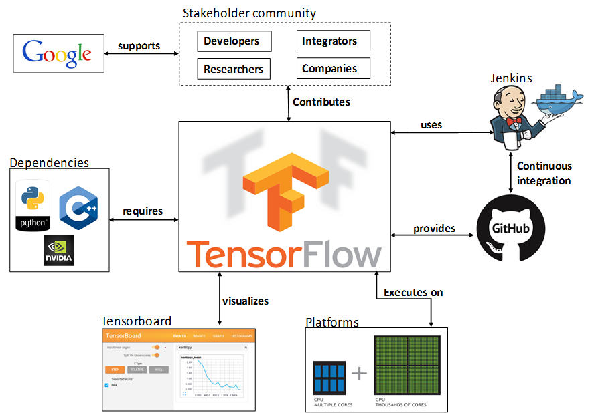
Fig1. TensorFlow

- TensorFlow is a community-driven framework supported by Google, used for machine learning and AI.
- It relies on Python, C++, and NVIDIA GPUs for performance and core operations. TensorBoard visualizes model performance with metrics and graphs.
- TensorFlow runs on CPUs, GPUs, and distributed systems for scalability.
- itHub and Jenkins enable continuous integration and automated testing

Google Cloud AI Platform:
This platform provides a range of services and infrastructure to build, train, and deploy machine learning models. It includes pre-built models, tools for custom model creation, and integration with other Google Cloud services like BigQuery for data handling. This system is especially valuable for interns who need to scale their AI solutions or handle large datasets.
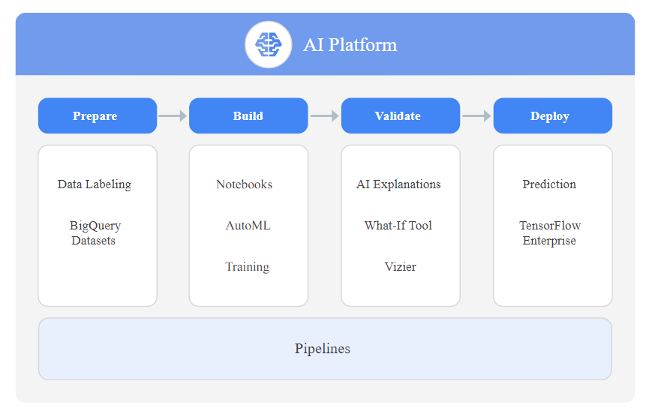
Fig2. Google AI Platform
- The Google AI Platform supports building and deploying models with data prep using BigQuery.
- The build phase includes Notebooks, AutoML, and custom training.
- Validation tools like AI Explanations, What-If Tool, and Vizier ensure model reliability.
- Models are deployed with TensorFlow Enterprise for real-time, scalable predictions. Pipelines streamline and automate the entire workflow for efficient model development.

Vertex AI:
A fully managed machine learning platform that simplifies the process of developing and deploying machine learning models. It supports various machine learning workflows, from data preparation and training to tuning and deployment.
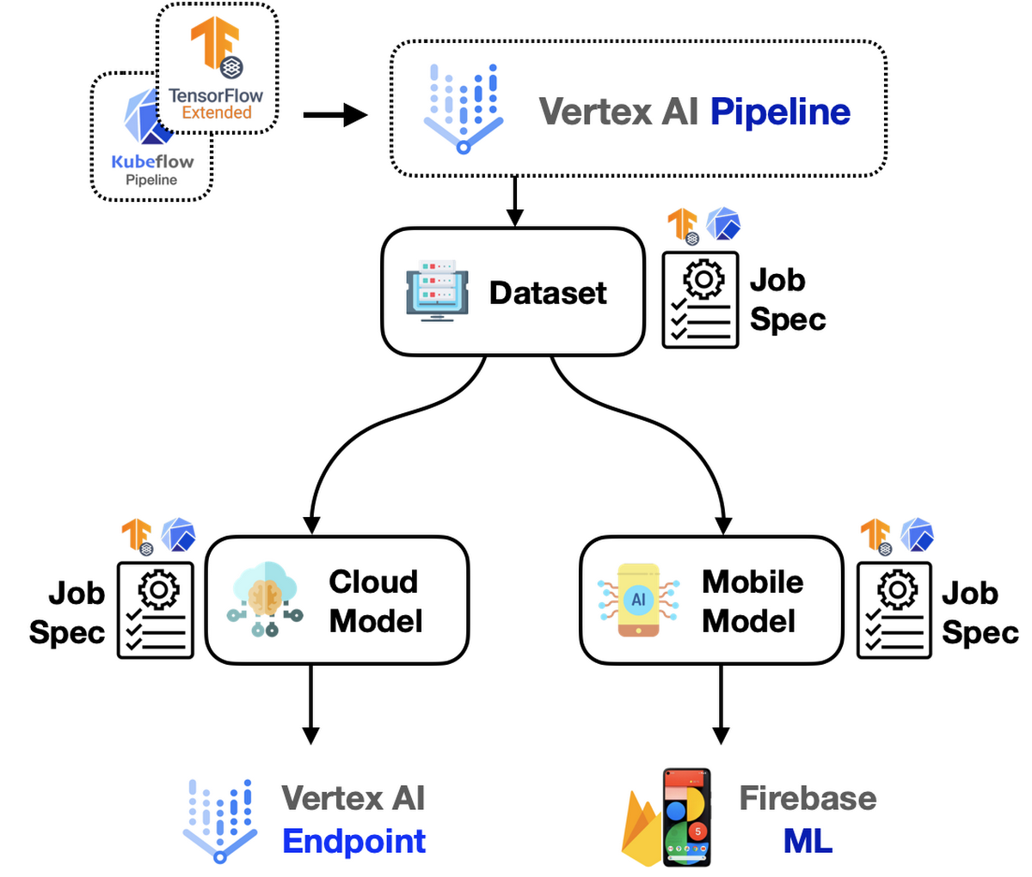
Fig3. Vertex AI

- The workflow uses Vertex AI, integrating TensorFlow Extended (TFX) and Kubeflow Pipelines for data preprocessing and model training.
- It produces two models: a Cloud Model for large-scale deployments and a Mobile Model for on-device tasks.
- The Cloud Model is deployed through Vertex AI Endpoints for scalable, server side applications.
- The Mobile Model is deployed via Firebase ML for low-latency, offline capabilities.
- This setup bridges cloud and mobile platforms, offering efficient, consistent AI solutions across use cases.
BigQuery:
A cloud-based data warehouse and analytics tool that helps interns manage and analyze large volumes of data efficiently. It is integral to handling datasets required for training machine learning models, especially in AI applications that require real-time data analysis.

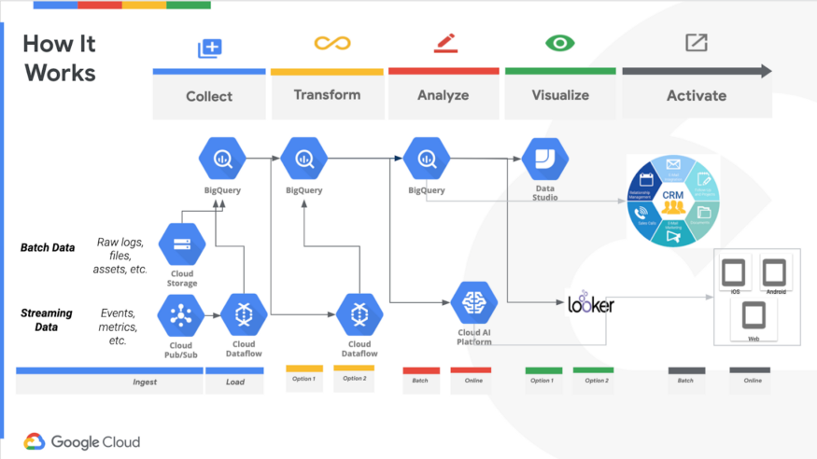
Fig4. BigQuery

- Data is collected via Cloud Storage (batch) and Cloud Pub/Sub (streaming).
- Cloud Dataflow processes and loads data into BigQuery for analysis.
- BigQuery and Cloud AI Platform enable advanced analytics and machine learning.
- Insights are visualized using Looker and Data Studio.
- Actionable insights are integrated into business tools for decision-making.

1.5 PROPOSED SYSTEM
A proposed system for Google AI-specific tools could involve enhancements and new integrations that align with evolving industry trends and educational needs. The goal is to make these tools more accessible, efficient for learners and developers. Key elements include :
Enhanced Automation and Integration:
- Introduce more intuitive tools within Vertex AI to automate processes like data preprocessing, hyperparameter tuning, and real-time model monitoring.
- Provide tighter integration between BigQuery and TensorFlow, allowing seamless transitions from data analysis to model building without significant manual effort.
AI Democratization:
- Develop a user-friendly interface for Google Cloud AI Platform, enabling non technical users or beginners to experiment with AI models through drag-and-drop capabilities or low-code/no-code environments.
- Expand the availability of pre-trained models optimized for various domains like healthcare, finance, and education.
Increased Educational Resources:
-Provide extensive learning modules integrated directly into tools like TensorFlow Hub, including guided projects and real-world case studies.
- Create simulation environments in Vertex AI to allow learners to test models in controlled, real-time scenarios.

- SYSTEM ANALYSIS

  - SOFTWARE REQUIREMENTS

Essential Software:
- Python: A versatile programming language widely used in AI/ML.
- Anaconda or Miniconda: A popular distribution for Python and data science packages.
- Jupyter Notebook: An interactive environment for data analysis and machine learning.
- Google Colaboratory: A free cloud-based platform for running Python code, including machine learning models.

Recommended Software:
- Visual Studio Code: A powerful code editor with extensions for Python development and AI/ML.
- Git: A version control system for tracking changes in code.

Necessary Libraries and Frameworks:
- NumPy: For numerical computations.
- Pandas: For data manipulation and analysis.
- Matplotlib and Seaborn: For data visualization.
- Scikit-learn: For machine learning algorithms.
- TensorFlow or PyTorch: For deep learning.
Note: While Google Colaboratory provides a free, cloud-based environment, having a local setup can be beneficial for offline work and more advanced projects.

2.2 HARDWARE REQUIREMENTS

While the Google AI/ML Virtual Internship primarily relies on cloud-based resources like Google Colaboratory, having a decent local machine can significantly enhance your learning experience, especially for larger projects or offline work.
Minimum Hardware Requirements:
- Processor: Intel Core i5 or equivalent (dual-core or better)
- RAM: 8GB or more
- Storage: 256GB SSD or HDD
- Graphics Card: Integrated graphics card is sufficient for most tasks. A dedicated GPU can accelerate deep learning tasks but isn't strictly necessary.
Recommended Hardware:
- Processor: Intel Core i7 or equivalent (quad-core or better)
- RAM: 16GB or more
- Storage: 512GB SSD or more
- Graphics Card: A dedicated GPU (NVIDIA GTX 1650 or higher) can significantly speed up deep learning tasks.

3. SYSTEM DESIGN

3.1 ARCHITECTURE

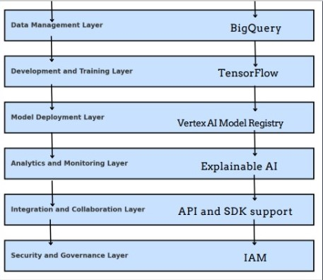

Fig5. Architecture

- Data Management Layer
- BigQuery: A fully managed, petabyte-scale data warehouse for storing and analyzing structured and semi-structured data. It's the foundation for data-driven AI projects.
- Development and Training Layer
- TensorFlow: An open-source machine learning framework for building and training a wide range of models, from deep learning to classical machine learning.
- Model Deployment Layer
- Vertex AI Model Registry: A centralized repository for storing, versioning, and managing trained models. It simplifies the deployment and scaling of models across different environments.
- Analytics and Monitoring Layer
- Explainable AI: Tools and techniques to understand and interpret model behavior, ensuring transparency and trust in AI decisions.
- Integration and Collaboration Layer
- API and SDK Support: Enables seamless integration of AI models into existing applications and workflows through APIs and software development kits (SDKs).
- Security and Governance Layer
- Identity and Access Management (IAM): Provides fine-grained control over who can access and manage AI resources, ensuring data security and compliance.

4. INTERNSHIP FEEDBACK

4.1 ABOUT THE COMPANY

The Google AI/ML Virtual Internship through AICTE Eduskills offers a unique opportunity to delve into the world of AI/ML. Google's global reach, innovative culture, and world-class infrastructure provide an ideal environment for learning and experimentation. The program's strong emphasis on mentorship, collaborative learning, and real-world project exposure empowers participants to develop practical skills and knowledge. While scaling the program and integrating more real-world projects could be experience for aspiring AI/ML professionals.

4.2 EXPERIENCE IN INTERNSHIP

The Google AI/ML Virtual potential areas for improvement, the internship overall provides a valuable
Internship through AICTE Eduskills was an invaluable experience that solidified my understanding of AI/ML concepts and provided hands-on practice. The comprehensive curriculum, coupled with expert mentorship, guided me through the intricacies of machine learning algorithms, deep learning techniques, and natural language processing.
I enjoyed working on real-world projects, such as image classification and sentiment analysis, which allowed me to apply theoretical knowledge to practical problem-solving. The collaborative learning environment fostered by the internship program enabled me to learn from my peers and develop valuable soft skills like teamwork and effective communication.

Overall, the internship significantly enhanced my technical skills and prepared me for a career in AI/ML. I am grateful for the opportunity to be part of this enriching experience and look forward to applying the knowledge and skills gained to contribute to the field of artificial intelligence.

4.3 CHALLENGES FACED
While the Google AI/ML Virtual Internship was an enriching experience, I encountered a few challenges.
Firstly, as a virtual internship, it required strong self-discipline and time management skills to stay motivated and consistent with the coursework. Balancing the demands of the internship with other commitments was sometimes challenging.
Secondly, the steep learning curve of advanced AI/ML concepts, particularly deep learning, required significant effort and dedication. Understanding complex algorithms and their implementation often posed hurdles.
Lastly, the virtual nature of the internship limited opportunities for in-person collaboration and networking with peers and mentors. While online platforms facilitated communication, face-to-face interactions can be more effective for building relationships and resolving complex technical issues.

5. CONCLUSIONS AND FUTURE SCOPE

The Google AI/ML Virtual Internship through AICTE Eduskills provided a comprehensive and immersive learning experience in the field of artificial intelligence and machine learning. The program's well-structured curriculum, expert mentorship, and hands-on projects equipped participants with the necessary skills to excel in this rapidly evolving field.
Key takeaways from the internship include:
- Strong Foundation: A solid understanding of fundamental AI/ML concepts, including supervised and unsupervised learning, neural networks, and deep learning.
- Practical Skills: Proficiency in using popular AI/ML tools and frameworks, such as TensorFlow and PyTorch, to build and deploy models.
- Problem-Solving Abilities: The ability to identify, formulate, and solve real-world problems using AI/ML techniques.
- Collaborative Skills: Experience in working in teams, sharing knowledge, and collaborating with peers.
- Lifelong Learning: A passion for continuous learning and staying updated with the latest advancements in AI/ML.

FUTURE SCOPE

The field of AI/ML is constantly evolving, with new breakthroughs and applications emerging regularly. To stay ahead of the curve, it is crucial to:
- Continuous Learning: Actively seek out opportunities for further learning, such as online courses, workshops, and conferences.
- Practical Experience: Gain hands-on experience through personal projects, open-source contributions, or internships.
- Networking: Build a strong network of AI/ML professionals to exchange ideas, collaborate on projects, and seek guidance.
- Ethical Considerations: Stay informed about the ethical implications of AI/ML and strive to develop AI systems that are fair, unbiased, and beneficial to society.
- Emerging Technologies: Explore emerging technologies like generative AI, reinforcement learning, and quantum machine learning to stay ahead of the curve.
By embracing these future directions, AI/ML enthusiasts can contribute to the development of innovative solutions and shape the future of technology.

BIBLIOGRAPHY
Textbooks:
- Hands-On Machine Learning with Scikit-Learn, Keras, and TensorFlow: Aurélien Géron
- Deep Learning: Ian Goodfellow, Yoshua Bengio, and Aaron Courville
- Pattern Recognition and Machine Learning: Christopher M. Bishop
Online Resources:
- Google Machine Learning Crash Course: Google AI
- TensorFlow and PyTorch Documentation: Official documentation from TensorFlow and PyTorch
- Kaggle: A platform for data science competitions and datasets
- GitHub: A platform for open-source projects and code repositories
Specific to the Google AI/ML Virtual Internship:
- Course Materials and Lecture Slides provided by Google and AICTE Eduskills
- Google Cloud Platform Documentation
- Google Colaboratory Tutorials and Documentation

Batch No: |  | Title
Roll No | Name | Title
22311A0569 | V. Sai Sri Lohitha | Google AI Specific Tools
22311A0572 | M. Sumedha | Google AI Specific Tools
22311A0570 | K. Varun Chandra | Google AI Specific Tools
Sreenidhi Institute of Science and Technology
Department of Computer Science and Engineering
Summer Industry Internship -1 (9E585)

ABSTRACT
The Google AI/ML Virtual Internship by AICTE Eduskills Cohort 10 provided an immersive platform to explore advanced AI/ML concepts. Participants gained expertise in supervised and unsupervised learning, neural networks, and computer vision while working hands-on with tools like TensorFlow, Google Cloud AI Platform, and Vertex AI. The program emphasized practical skills through real-world projects, preparing interns to design and deploy scalable AI solutions.
Mentorship from industry experts and collaborative projects enriched the learning experience, fostering technical proficiency and soft skills like teamwork and communication. Key projects included sentiment analysis and generative AI, showcasing applications in healthcare and finance. The program also stressed ethical AI practices and innovation.
Despite challenges like mastering complex algorithms and balancing commitments, the internship provided a rigorous and rewarding experience. It equipped participants with essential skills, fostering readiness for impactful careers in artificial intelligence.

Student 1 22311A0569 Internal Guide HOD
Student 2 22311A0572 Dr. K C Sreedhar Dr . Aruna Varanasi
Student 3 22311A0570 (Associate Professor)
Batch No: |  | Title
Roll No | Name | Title
22311A0569 | V. Sai Sri Lohitha | Google AI Specific Tools
22311A0572 | M. Sumedha | Google AI Specific Tools
22311A0570 | K. Varun Chandra | Google AI Specific Tools

Table 1: Project correlation with appropriate POs/PSOs (Please specify level of Correlation, H/M/L against POs/PSOs)
H | High | M | Moderate | L | Low
SREENIDHI INSTITUTE OF SCIENCE AND TECHNOLOGY
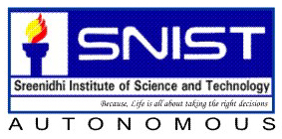
DEPARTMENT OF COMPUTER SCIENCE AND ENGINEERING
Projects Correlation with POs/PSOs
PO1 | PO2 | PO3 | PO4 | PO5 | PO6 | PO7 | PO8 | PO9 | PO10 | PO11 | PO12 | PSO1 | PSO2 | PSO3
H | H | H | M | H | L | L | M | H | M | M | H | H | H | H

Student 1 22311A0569 Internal Guide HOD
Student 2 22311A0572 Dr. K C Sreedhar Dr . Aruna Varanasi
Student 3 22311A0570 (Associate Professor)

Batch No: |  | Title
Roll No | Name | Title
22311A0569 | v. Sai Sri Lohitha | Google AI Specific Tools
22311A0572 | M. Sumedha | Google AI Specific Tools
22311A0570 | K. Varun Chandra | Google AI Specific Tools
Table 2: Nature of the Project (Please tick √ Appropriate for your project)
Batch No. | Title | Nature of Project
Batch No. | Title | Product | Application | Research
 | Google AI Specific Tools |  | √

Student 1 22311A0569 Internal Guide HOD
Student 2 22311A0572 Dr. K C Sreedhar Dr . Aruna Varanasi
Student 3 22311A0570 (Associate Professor)

Table 3: Domain of the Project (Please tick √ Appropriate for your project)

Batch No. | Title | Domain of the Project
Batch No. | Title | COMPUTER NETWORKS, CLOUD COMPUTING, INFORMATION SECURITY, CYBER SECURITY, DATA SCIENCE, DATA MINING AND IOT | ARTIFICIAL INTELLIGENCE, MACHINE LEARNING AND DEEP LEARNING | INTERNET OF THINGS, DATA WAREHOUSING , DATA MINING, BIG DATA ANALYTICS | SOFTWARE ENGINEERING, SOFT COMPUTING
 | Google AI Specific Tools |  | √

Student 1 22311A0569 Internal Guide HOD
Student 2 22311A0572 Dr. K C Sreedhar Dr . Aruna Varanasi
Student 3 22311A0570 (Associate Professor)

